Primary Media Contact:  Advantech Europe B.V.  Barbara Tritscher  Tel: +49 (0) 89 12599 1038  Barbara Tritscher@advantech.de |  |  | 2nd Media Contact:

New COM-Ultra Module Targets Ruggedized Applications
and Extended Temperature Capabilities

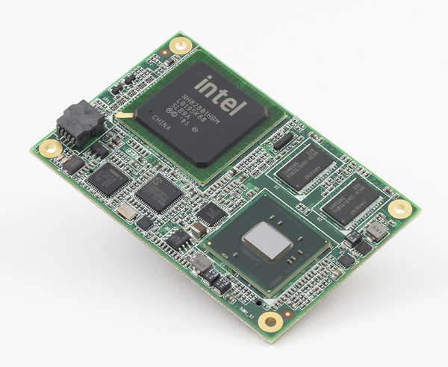
March, 2, 2011–Advantech, a global embedded computing leader providing embedded platform solutions across multiple vertical markets through deployment of intelligent applications and services, today announced the release of SOM-7562 B1 COM-Ultra Module based on the Intel N455 processor. The new B1 version module with N455 processor from Intel incorporates upgraded memory technology from DDR2 to DDR3, wider temperature (-40 ~ 85° C) provision, and an optional 5V-only version with more competitive power consumption.

Compact Design with Onboard System Memory and Flash Disk
SOM-7562, the first COM-Ultra low power solution released last year, is especially suited to portable device applications since the N455 platform is integrated in a compact board (84 x 55 mm) as small as a credit card. Power consumption is fully utilized to give good performance with great power saving. An all-in-one solution with system memory and flash disk onboard, SOM-7562 performs stably under high vibration environments and the whole design is super compact for space limited applications.

New Generation Intel Atom Platform with DDR3 Memory
The inherited compact form factor, software utility support, and all-in-one solution advantage from the A1 version, SOM-7562 B1 further upgrades memory capacity from 512 MB to 1 GB, making systems run more even smoothly. The Intel N455 processor has been upgraded to support DDR3 with better performance than DDR2, and incorporates better energy saving technology.

Ruggedized Design & Low Power Consumption
With its rock solid design, SOM-7562 B1 proves its ability under extended temperature environments of between -40 ~ 85° C, and under high vibration conditions of 3.5 Grms with a frequency 5-500Hz, which makes ideally suited for a wide variety of demanding applications. For those customers especially looking for low power consumption, other than optimization of BIOS features, SOM-7562 B1 could be optionally engineered to run on as low as 5 volts. The 5V only version reduces as much as 1 watt power consumption with standard 12V power supply, providing customers with another way to improve power efficiency. SOM-7562 B1 version COM-Ultra Module is available now, please contact your local sales or visit the website for more details.

Features:
- Built-in Intel N455 processor with 1 GB on-board memory and 2 GB flash disk
- Supports extended working temperatures of between -40 ~ 85° C
- Qualified for ruggedized environments up to 3.5 Grms (random vibration) and 15 G (bump)

About Embedded Core Service
Advantech Embedded Core Services offers design-in oriented services. These streamlined solutions broadly integrate embedded boards, peripheral modules and software. This dedicated focus on Embedded Design-in services fulfills electronic engineering demands at their design-in phase, and brings benefits that shorten the design and integration cycle, minimizing uncertainty and risk. www.advantech.eu/EmbCore

About Advantech
Founded in 1983, Advantech is a leader in providing trusted, innovative products, services, and solutions. Advantech offers comprehensive system integration, hardware, software, customer-centric design services, embedded systems, automation products, and global logistics support. We cooperate closely with our partners to help provide complete solutions for a wide array of applications across a diverse range of industries. Our mission is to enable an intelligent planet with Automation and Embedded Computing products and solutions that empower the development of smarter working and living. With Advantech, there is no limit to the applications and innovations our products make possible. (Corporate Website: www.advantech.eu).

